Ambiguous Pronoun Reference
Student Name:
Instructor:
Date:
Course:

About this DLA

Important Note
All the activities (3) in the DLA must be completed in their entirety before receiving credit for completion. Students are welcome to meet with a tutor if they need help, but please be aware that students might need a second appointment for review and signature in that case. If your instructor wants evidence of this completed DLA, return this form to him or her with the tutor’s signature included.

Learning Outcomes
Through computer and other independent work, this activity will familiarize you with and help you create sentences that avoid ambiguous pronoun reference in your writing.

Activities (approximately 1 hour)
Read the information, complete the activities that follow, and be prepared to discuss your answers when you meet with a tutor.

Understanding Pronouns
A pronoun is a word that takes the place of a noun. We use pronouns to avoid repeating a word again and again. The antecedent is the word or words that a pronoun replaces.
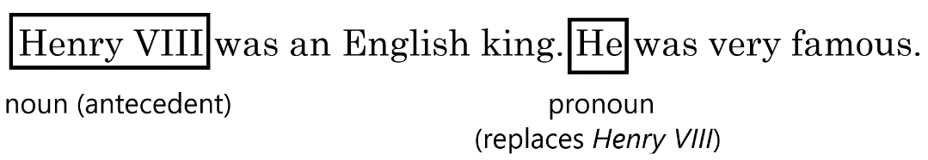
- Henry VIII was an English king. He was very famous.
In the above sentences, Henry VIII is the antecedent and He is the pronoun.
Because a pronoun is taking the place of an antecedent, the connection between the pronoun and antecedent must be clear. That is, we should be able to easily identify the antecedent to which the pronoun is referring. In some sentences, gender and number make that connection clear.
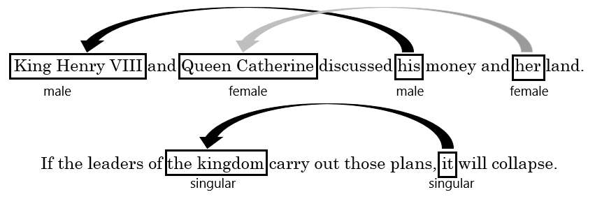
- King Henry VIII and Queen Catherine discussed his money and her land.
The reader knows the money belongs to King Henry VIII and the land belongs to Queen Catherine.
- If the leaders of the kingdom carry out those plans, it will collapse.
The kingdom is singular, so the reader knows the kingdom will collapse, not the leaders.

Problems with Pronouns
Some sentences can be confusing when they have more than one possible antecedent for the pronoun, or when there is no clear antecedent. We call this confusion ambiguous pronoun reference.
Unclear | Clear
The king told his friend that his days were numbered.  Whose days are numbered, the king’s or his friend’s? | The king told his friend, “Your days are numbered.

Things to Remember
- Avoid using pronouns that could refer to more than one antecedent.
Unclear | Clear
King Henry VIII had his friend and his wife executed.  Whose wife, the king’s or his friend’s? | King Henry VIII had his wife and his friend executed.  The king’s wife and the king’s friend were executed.
King Henry VIII had his friend and his friend’s wife executed.
The king’s friend and the friend’s wife were executed.
- Avoid using it or they if the pronoun has no clear antecedent.
Unclear | Clear
They say that Henry VIII had many enemies.  Who are they? | Historians say that Henry VIII had many enemies.
It states in the book that Henry VIII was married six times.  What is it? | The book states that Henry VIII was married six times.
- Use this, that, and which only to refer to a specific antecedent and not to a group of words.
Unclear | Clear
The Catholic Church did not let Henry VIII divorce his first wife. This drove the king to create his own church. | The Catholic Church did not let Henry VIII divorce his first wife. This denial drove the king to create his own church..
Henry VIII refused to obey the Catholic Church, which Reformers loved.  Did Reformers love the Catholic Church or the fact that Henry refused to obey it? | Reformers loved Henry VIII’s refusal to obey the Catholic Church.
- Make sure that clauses beginning with who, which, and that are as close as possible to the nouns they are describing. *For more information, see the Dangling and Misplaced Modifiers DLA.
Unclear | Clear
Henry wrote poems for Catherine that were as beautiful as she was.  Was Catherine as beautiful as she was? | Henry wrote Catherine poems that were as beautiful as she was.
- Avoid using pronouns that have hidden antecedents.
Unclear | Clear
The king complemented Anne’s beauty, but she initially refused his advances.  (She obviously refers to Anne and not her beauty, but there is no direct mention of Anne.) | The king complemented Anne’s beauty, but Anne initially refused his advances.  The king complemented Anne, but she initially refused his advances.

How to Fix Ambiguous Pronoun Reference
- Replace an ambiguous pronoun with a noun.
Unclear | Clear
They say that Henry VIII may have had Type II diabetes. | Historians say that Henry VIII may have had Type II diabetes.
- Change reported speech to quoted speech.
Unclear | Clear
The courtier told the king that he had had an affair with his wife. | The courtier told the king, “I had an affair with your wife.”
- Rephrase the sentence.
Unclear | Clear
The queen had an affair with a courtier, which enraged the king. | The queen’s affair with a courtier enraged the king.
- Add a noun after the words this or that.
Unclear | Clear
The corpulent king had to be moved around by mechanical devices. This caused him to gain ever more weight. | The corpulent king had to be moved around by mechanical devices. This lack of mobility caused him to gain ever more weight.

Activities:
Check off each box once you have completed the activity.

☐ 1. Online Quiz
Go to http://tinyurl.com/AmbiguousPronounDLAQuiz and take the Ambiguous Pronoun DLA Quiz. You must score at least 80% on the quiz before meeting with a tutor. After you complete the task, PLEASE ASK A LAB TUTOR OR FRONT DESK ATTENDANT TO PRINT THE PAGE THAT HAS YOUR SCORE. DO NOT EXIT THE PROGRAM UNTIL THIS PAGE HAS BEEN PRINTED (FREE OF CHARGE).

☐ 2. Sentence Correction
Review the above information on ambiguous pronoun reference, and then read the following sentences. Identify whether each is correct (C), or has an ambiguous pronoun (AP). If there is an error, correct it using one of the methods discussed above.

C or AP | Sentence
 | - Henry sought the advice of Thomas Moore, a close confidant, but he was later
 | beheaded and is now a saint in the Catholic Church.
 | - The Pope told Henry that he could not get a divorce, which angered Henry.
 | - The king saw a man walking with Queen Anne, the king’s wife.
 | - They say that the king spent a lot of money.
 | - Henry’s incessant eating annoyed his wife.
 | - The article states that Henry’s third wife died from an infection.
 | - The wine bottle was empty, but the king was tired of drinking it anyway.
 | - Henry was an accomplished musician, and he did it almost every day.
 | - The king divorced Anne of Cleves because she had been previously engaged.
 | - The king’s organ playing was so loud that he woke up the queen.
 | - Jane Seymour was Queen Anne’s lady-in-waiting. This job changed Jane’s life.
 | - Because the king’s fifth wife cheated on him, she sealed her fate.
 | - The king got butterflies in his stomach every time he talked to Anne.
 | - It says in the newspaper that the king was a Renaissance man.
 | - Henry wanted to divorce his first wife, but this was not possible because the Catholic
 | forbade it.

Choose 3a or 3b Below

☐ 3a. Correct Your Own Writing
Collect some of your graded work that identifies ambiguous pronoun errors. Correct all marked errors and look for others to correct as well. Bring this revised work with you to the DLA tutoring session.
If you do not have your own essay to work with, please complete the supplemental activity below (3b).

☐ 3b. Rewrite Ambiguous Pronoun References
On a separate sheet of paper, re-write the following ambiguous sentences.
- The commanders told the soldiers that they would receive a bonus.
- The midwife told the queen that her baby was weak.
- They say that Henry VIII wrote the song “Greensleeves.”
- Henry ordered two of his six wives to be executed. This is disgraceful.
- The king executed people who stood in his way, which caused fear.

☐ 4. Review the DLA
Go to https://mtsac2.mywconline.com and use the Mt. SAC Writing Center Appointment System to make a DLA appointment, or sign-up to see a tutor on the “Walk-in” list in the Writing Center. During your session with a tutor, explain pronoun reference. Refer to your own graded writing (or the completed activity) and explain to the tutor strategies that you used to identify ambiguous pronoun reference and how knowledge of this can help improve your writing style. Consider the main concept you learned in this DLA. How will knowledge of these concepts affect your writing?
Student’s Signature:
Tutor’s Signature
Date:
Date:
If you are an individual with a disability and need a greater level of accessibility for any document in The Writing Center or on The Writing Center’s website, please contact the Mt. SAC Accessible Resource Centers for Students, access@mtsac.edu, (909) 274-4290.
Revised 06/22/2022

