Connotation and Denotation
Type your information in the space below.
Student Name: | Date:
Instructor: | Course:

About This DLA

Important Note
All the activities (4) in the DLA must be completed in their entirety before receiving credit for completion. Students are welcome to meet with a tutor if they need help, but please be aware that students might need a second appointment for review and signature in that case. If your instructor wants evidence of this completed DLA, return this form to him or her with the tutor’s signature included.

Learning Outcome
Through computer and other independent work, this activity will familiarize you with the differences between connotation and denotation in order to help you make appropriate use of diction (word choice) in your college writing assignments.

Activities (approximately 1 hour)
Read the information, complete the activities that follow, and be prepared to discuss your answers when you meet with a tutor.

Understanding Denotation
Denotation is the literal meaning of a word. It’s the definition you would likely find in a dictionary. For example, the words house and home have the same denotation. In other words, both mean “a place where people live,” but the fact that they are synonyms doesn’t necessarily mean that they are both used in the same contexts. In other words, they don’t have the same connotative meaning (see below).

Understanding Connotation
Connotation refers to the emotional, social, and cultural associations attached to a word.
For example:
The words house and home have different connotative meanings. For instance, people tend to use the word home to refer to where they live since this word is generally associated with a place that usually offers comfort, love, privacy, etc. On the other hand, a contractor is more likely to use the word house when discussing projects that need to be done at someone else’s home (since the contractor likely has no emotional attachment to a client’s house).

Negative, Neutral, and Positive Connotation
The connotation of words can be more negative, neutral, or positive (in large part depending on the context). For instance, the words child, brat, and kiddo all refer to a “young person,” but the connotation varies:
The word child usually carries a neutral connotation.
The word brat usually carries a negative connotation.
The word kiddo usually carries a positive connotation.
The connotation of the same word may also vary, though. For instance, depending on the context, the word child may have a negative—as opposed to a neutral—connotation (when being used to criticize an adult for behavior you consider to be immature, for example).
That child is very sweet. I’m mad at my husband. He is such a child!

(neutral)
(negative)

It is also helpful to think of connotations in a spectrum since some words and their synonyms might carry varying degrees of negative connotations but not positive, and vice-versa.
As you can see in the spectrum below, the synonyms criminal, unlawful, and wrong generally carry more or less negative connotations, but not positive.
criminal unlawful wrong

NEGATIVE
NEUTRAL
POSITIVE

Intensity
Aside from negative, neutral, and positive connotations, words may also carry varying degrees of intensity.
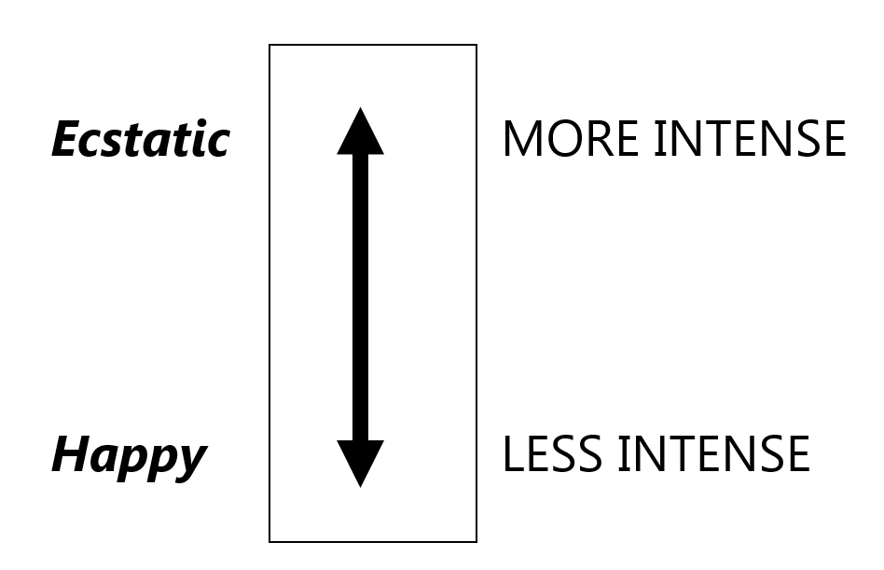
While both of the synonyms happy and ecstatic generally carry a positive connotation, ecstatic is perceived as more intense than happy (“happier than happy”), as shown in the above spectrum.
Note that there are other spectrums that may apply to different words since there may be many subtle differences in meaning. Below are a few of many other factors to consider when choosing a word with the appropriate connotation.

Other Factors

Formality
The words fashionable and cool are listed as synonyms in dictionaries, but the level of formality socially attached to them is different. For example, a college student might use the word cool to describe a friend’s stylish clothes. On the other hand, when describing something stylish in a formal essay for a class assignment, that same student would need to use a more formal word which, in this case—if presented with the above two options—would be the word fashionable.

Gender
Although the words beautiful and handsome are synonyms, beautiful is normally used to describe females and handsome is used for males. The same goes for words such as bombshell (used for women) vs. heart-throb (used for men), spinster (used for women) vs. bachelor (used for men), etc.

Age/Maturity
While the word cute is often used to describe small children, it likely won’t be well received as a compliment to teenagers or adults. Teens and adults normally prefer to be complimented with words such as beautiful, handsome, gorgeous, pretty, etc. Other examples are tummy (used by children) vs. stomach (used by adults), booboo (used by children) vs. injury (used by adults), etc.
Aside from the above, there are many other differences in connotative meanings that affect our word choice.

The Importance of Connotation
- When communicating with others, we need to be able to express ourselves with clarity and precision. To do so, it is important to know when a word carries a negative, neutral, or positive connotation because, for instance, you probably wouldn’t want to offend a parent by calling his or her child a brat when you were actually trying to be nice and really just meant child.
- Moreover, when writing, your diction (choice of words) generates different effects or emotions on readers. If you use the right connotation to express the meaning you want, your writing will be much more effective and you won’t run the risk of confusing, offending, or alienating your readers.
Let’s say for instance that you are writing an informational paper, and you don’t want to influence the reader to favor or disfavor a theory. In this case, you might choose to use words with a neutral connotation. On the other hand, if you are writing an argument and you want the reader to disfavor a certain theory, then you will likely use words with negative connotations when referring to the opposing view and words with positive connotations when referring to your views. Look at the examples below and notice the different effect that words with different connotations have on the overall meaning of the sentence and the reader’s perception of the information.

1. My sister is a very determined girl.
2. My sister is a very stubborn girl.
3. Tom made a series of mistakes.
4. Tom committed a series of crimes.

As it has probably become clear to you in the above examples, the use of the word determined in sentence 1 carries a more positive connotation while the use of the word stubborn in sentence 2 leads readers to form a more negative image of the girl. Likewise, in the second pair of sentences, the words made and mistakes are less negative than the words committed and crimes. After reading sentence 4, a person might have a much more negative impression of Tom and the situation than after reading sentence 3.

Determining Which Word to Use in a Specific Context
When you use a new word in your sentence, and you are not sure if it has the correct connotation you are seeking, search for it in different sources and see how it is used in contexts that are similar to your context so that you get a sense of its connotative meaning. In other words, see how others have used it in sentences they wrote so that you understand whether the word generally carries either a negative, neutral, or positive connotation and whether or not it has the exact meaning you want to express. You can do that by looking through printed materials, talking to others, or searching for the word on the web [preferably on reliable websites such as those created by educational institutions (.edu), the government (.gov), or reputable news sources such as newyorktimes.com—especially if you are writing something formal].
If you find that the word has the right definition but not the correct connotation you want, then search for synonyms in a thesaurus and follow the above process again to find out the connotation of your new word.
Some good online dictionaries are the Learner’s Dictionary (http://www.learnersdictionary.com/) and Longman Dictionary (https://www.ldoceonline.com/), which are great for English learners, or Merriam Webster (https://www.merriam-webster.com/). You can download dictionary and thesaurus apps to your phone to make it easier to look up words.
Also, to learn more about finding and selecting correct words and synonyms, refer to our “Dictionary Skills” and “Thesaurus Skills” DLAs.

Activities
Check off each box once you have completed the activity.

☐ 1. Review connotation and denotation
Using your own words, answer the following questions.
- What is denotation?
Type you answer in the space below.
- What is connotation?

Type you answer in the space below.

☐ 2. Online Quiz
Go to http://tinyurl.com/ConnotationsDenotationsDLAQuiz and take the Connotations and Denotations DLA Quiz. You must score at least 80% on the exercises before seeing a tutor. After you complete the task, PLEASE ASK A LAB TUTOR OR FRONT DESK ATTENDANT TO PRINT THE PAGE THAT HAS YOUR SCORE. DO NOT EXIT THE PROGRAM UNTIL THIS PAGE HAS BEEN PRINTED (FREE OF CHARGE). If you have any other questions, do not hesitate to ask a lab tutor.

☐ 3. Practice Finding the Correct Word
Read the word below and answer the questions that follow. Use a dictionary and thesaurus or the following links.
Longman Dictionary (http://www.ldoceonline.com)
Merriam Webster Dictionary (https://www.merriam-webster.com/)
Thesaurus (http://www.thesaurus.com/)
You can also use the Writing Center’s dictionaries, which are available on the shelves by the couches in our tutoring area.
Word: Gargantuan
Denotative meaning (from the dictionary):
Type you answer in the space below.

Synonyms (from a thesaurus):
Type you answer in the space below.
Select three of the synonyms you wrote above and use them in sentences in which they carry varying degrees of connotations. (Think of the spectrums on page 2.) If you are not sure about the connotative meaning of a word, follow the steps described under “How can you find out which word you should use in a specific context?” on page 4.
Type you answer in the space below.
a.
b.
c.
Now use the lines below to indicate whether the synonyms in each of the sentences you wrote above carry a more positive, negative, or neutral connotation.
Type you answer in the space below.
a.
b.
c.

Choose activity 4a or 4b below.

☐ 4a. Apply What You Have Learned to Your Own Writing
Collect some of your written work. Find sentences with words exemplifying different connotations and write them below. Once you write each sentence, underline the word with the requested connotation. Then answer the questions that follow.
Type you answer in the space below.
Positive connotation:
Neutral connotation:
Negative connotation:
Are the words you chose for each of your above sentences the most appropriate for the meaning you intended? For instance, did you choose the words with the correct connotation and level of formality? If not, which word(s) would have been more appropriate for the context and why? Answer in the space below.
Type you answer in the space below.
If you do not have sentences from your own writing to work with, please complete the supplemental activity below (4b).

☐ 4b. Write Your Own Sentences
Write a sentence of your own in A below. Then choose one of the words in the sentence you wrote and look up two synonyms for that word. Write a sentence with each synonym in B and C below. Underline the synonyms and be prepared to explain to the tutor the connotation of each synonym in your sentences. Don’t forget to utilize the strategies explained on this handout when looking up words.
Type you answer in the space below.
a.
b.
c.

☐ 5. Review
Go to https://mtsac2.mywconline.com and use the Mt. SAC Writing Center Appointment System to make a DLA appointment, or sign-up to see a tutor on the “Walk-in” list in the Writing Center. During your session with a tutor, explain your work to demonstrate your understanding of denotation and connotation. Refer to your own graded writing (or the completed activity) and explain to the tutor the strategies that you used to improve your diction (choice of words) in your writing.
Sign and date in the space below.
Student’s signature: | Date:
Tutor’s Signature: | Date:
If you are an individual with a disability and need a greater level of accessibility for any document in The Writing Center or on The Writing Center’s website, please contact the Mt. SAC Accessible Resource Centers for Students, access@mtsac.edu, (909) 274-4290.
Revised: 04/12/2022

