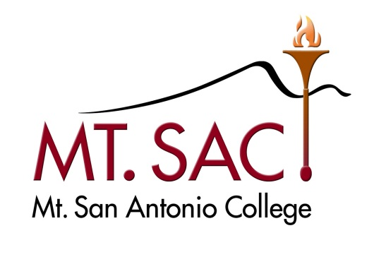
President’s Cabinet
Action Notes
July 19, 2011
Bill Scroggins, President/CEO
Virginia Burley, VP of Instruction
Audrey Yama, VP of Student Services
Mike Gregoryk, VP of Administrative Services
Annette Loria, VP of Human Resources
- The Unrestricted General Fund 11 Budget and Expenditure Reports for the last two fiscal years were discussed line by line. Linda Baldwin joined Cabinet for the discussion. Both the 09-10 and 10-11 reports that were discussed are attached. Cabinet got through the units reporting to the President and to Instruction. The rest of the units will be discussed at the Cabinet meeting on July 26. Linda will provide a summary of the changes made so far for review at the 7/26 Cabinet meeting. In addition to line item changes, the budget review triggered a number of other discussions.
- There is a need for a budget to pay for substitutes. Institutional accounts will be created by Linda for both academic and classified substitutes at $50,000 each.
- The allocation of faculty Travel and Conference funds will be straightened out by Ginny and Linda.
- A question arose about the legality of the way we are funding student travel. Mike will review the Chancellor’s Office legal opinion and report back at the August 2nd Cabinet meeting.
- An analyst position was authorized for HR.
- Resources for professional development were discussed. Bill will continue to develop potential solutions and will update Cabinet regularly.
- The potential for centralizing printing and copying was discussed. The need for a considerable capital investment to make this possible was recognized. The college should prepare for this option and look for opportunities to secure this initial capital funding. Mike will research the possibilities for centralized printing and copying and report to Cabinet on August 2nd.
- At Cabinet on July 26, the unfinished budget line item analysis will be completed. The positive variance analysis will be discussed with the goal of better aligning anticipated revenues and expenditures with actuals. VPs will also report on budget reductions to be implemented from Level 1 PATF recommendations.
- The work on the 26th should proceed well enough to provide agenda material for both the President’s Advisory Task Force on Fiscal Planning and the Budget Committee. Mike will call for these two meetings as soon as possible.
- Items for future agendas:
  - Education/Information Reports to the Board
  - Institutional Memberships
  - BP and AP 6625 on District Fundraising (Mike, 9/20)
  - Student Travel Legal Opinion (Mike, 8/2)
  - Centralized Printing and Copying (Mike, 8/2)

