SLP7. Telling Time

Pair #
STOP: Before you begin this activity, open and follow recording instructions here.

Partner A:
Student ID:
Instructor:
Language:
Level: Date:
Partner B:
Student ID:
Instructor:
Language:
Level: Date:

Section 1: Vocabulary Mastery
Instructions: Describe the sign of the following words and phrases using the 5 Parameters of ASL. Try to use your book and your partner before using other materials or the internet. Use the third column to help you remember the sign in your target language (ASL) by drawing a picture or writing a note to yourself.
Time Vocabulary | 5 Parameters of ASL  Description | Notes/Pictures/Sign Guide  (anything to help you)
- What time is it?
- It’s noon.
- It’s midnight.
- It’s one o’clock.
- It’s one fifteen.
- It’s one thirty.
- It’s one forty-five.
- It’s two o’clock.
- It’s two forty.
- It’s twenty to three.
- It’s a quarter to three.
- It’s five to three.
- It’s three fifty.
- At what time do you wake up?
- At what time do you go to sleep?

Section 2: TV Schedule
Instructions: It’s Tuesday night, your internet is down, and all you can watch is network television. Your partner will use the TV schedule to ask you in your target language (ASL) when a certain show will be on. Each partner will ask about 3 shows. Answer their questions and switch roles.
Student A: At what time is iZombie?
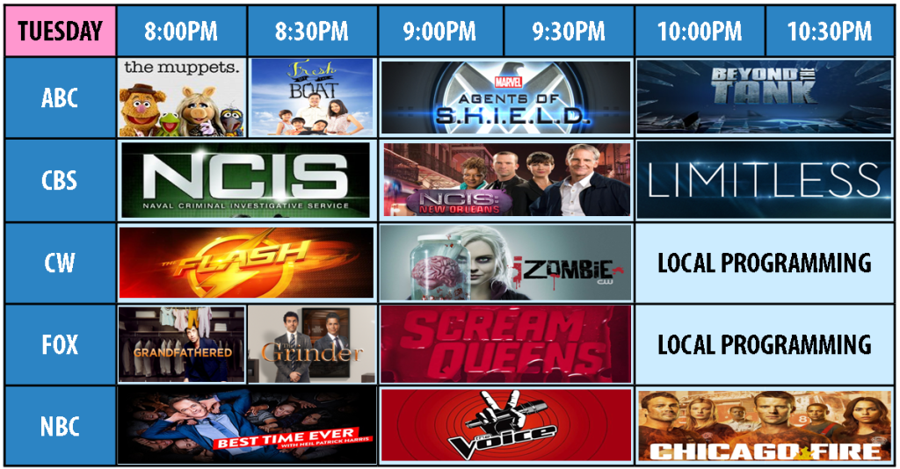
Student B: It’s at 9pm.
Retrieved from Twocentstv.com on 5/5/17

Section 3: What time is it in…?
Instructions: Go to https://greenwichmeantime.com/timepiece/world-clock/world/ and enter the cities #1-6. Tell your partner the time in that city. Optional: You can also show your partner the countries you want to travel to and find the time there too.
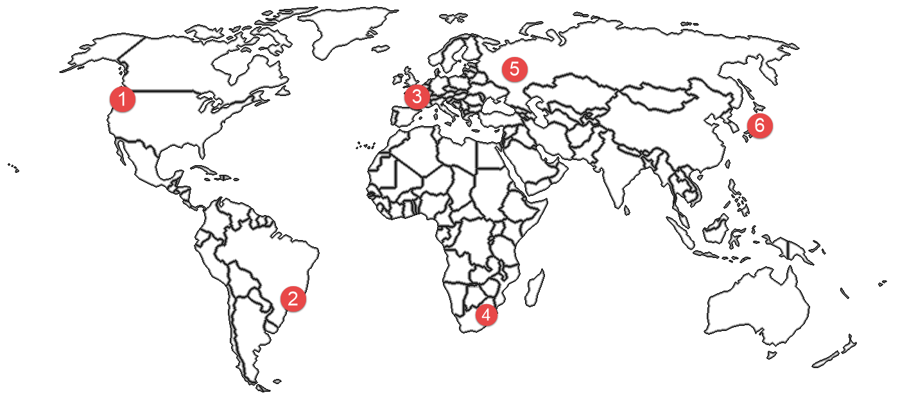

Example in ASL: Los Angeles (LA) afternoon 4 (from wrist).

- ________________________________________________
- ________________________________________________
- ________________________________________________
- ________________________________________________
- ________________________________________________
- ________________________________________________
Answers: 1. Seattle, 2. Rio de Janeiro, 3. Paris, 4. Johannesburg, 5. Moscow, 6. Tokyo

Section 4: Create a Dialogue
Instructions: What is your typical day at Mt. SAC? Ask your partner, for example, when they: leave their house, arrive on campus, eat breakfast, go to class, study, go to work, hang out with friends, etc. Switch roles and answer your partner’s questions. Write your conversation here. Attach another piece of paper if you need more space. You will record this dialogue in the next section. Ask for help when necessary.
Signer 1:
Signer 2:
Signer 1:
Signer 2:
Signer 1:
Signer 2:
Signer 1:
Signer 2:

