SLP6. Locations and Directions

Pair #
STOP: Before you begin this activity, open and follow recording instructions here.
Partner A:
Student ID:
Instructor:
Language:
Level: Date:
Partner B:
Student ID:
Instructor:
Language:
Level: Date:

Section 1: Vocabulary Mastery
Instructions: Describe the sign of the following words and phrases using the 5 Parameters of ASL. Try to use your book and your partner before using other materials or the internet. Use the third column to help you remember the sign in your target language (ASL) by drawing a picture or writing a note to yourself.
Vocabulary | 5 Parameters of ASL Description | Notes/Pictures/Sign Guide  (anything to help you)
- Right
- Left
- Around
- On top
- Under
- In front of
- Facing across
- Next to
- Hospital
- School
- Park
- Straight ahead
- On the corner/around the corner
- North/South/East/West
- Behind
- Here/there/ near

Section 2: Directions
Instructions: Use the textbook and your partner to help you write the following directions using ASL syntax (word order).
The hospital is around the corner.

The park is across from the school.

Turn left.

Turn right.

The supermarket is next to the restaurant.

Section 3: Town Map
Instructions: Review the town map below. Using your textbook and your partner’s help, give your partner the directions for the locations you must get to in #1-4.
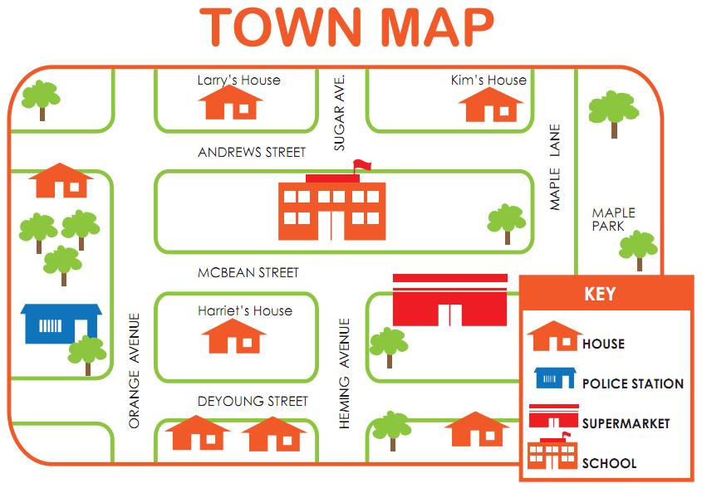
- You are at Kim’s house, how do you get to the police station?
- You are at Larry’s house. How do you get to the supermarket?
- You are at Maple Park. How do you get to a house on Orange and Andrews Street?
- You are at Harriet’s house. How do get to Kim’s house?

Section 4: Creating a Dialogue
Instructions: Each partner will select a different place they need to go to on the Mt. SAC campus. (Refer to the campus map on the next page.) Your partner will give you directions to each of the three places. You will begin at the LLC (Building 77). Use your textbook and partner to help navigate you on your journey. Write your conversation here. Attach another piece of paper if you need more space. You will record this dialogue in the next section. Ask for help when necessary.
Signer 1:
Signer 2:
Signer 1:
Signer 2:
Signer 1:
Signer 2:
Signer 1:
Signer 2:

