SLP3. Home

Pair #
STOP: Before you begin this activity, open and follow recording instructions here.

Partner A:
Student ID:
Instructor:
Language:
Level: Date:
Partner B:
Student ID:
Instructor:
Language:
Level: Date:

Section 1: Vocabulary Mastery
Instructions: Describe the sign of the following words and phrases using the 5 Parameters of ASL. Try to use your book and your partner before using other materials or the internet. Use the third column to help you remember the sign in your target language (ASL) by drawing a picture or writing a note to yourself.
Vocabulary | 5 Parameters of ASL Description | Notes/Pictures/Sign Guide (anything to help you)
- an oven
- a bathroom
- a couch
- a kitchen
- a bedroom
- a chair
- a bed
- a living room
- a refrigerator
- a rug
- an apartment

Section 2: Verbal Expressions
Instructions: Write the expressions used when talking about a home, a house, or the furniture using ASL syntax (word order). Practice signing with your partner taking turns. When it asks to translate, please write the expression in ASL syntax (word order).
Ask: “Where is the kitchen?” (translate)
Answer: “Here is the kitchen.” (translate)
Practice asking and answering with each item on the vocabulary list.
Ask: “Where is the ?”
Answer: “Here is a/the .”

Section 3: Interior and Exterior Home Description
Instructions: Draw rectangles to represent furniture in the house. Label the rooms. Use your textbook and your partner’s help to talk about the interior and exterior parts of this home.
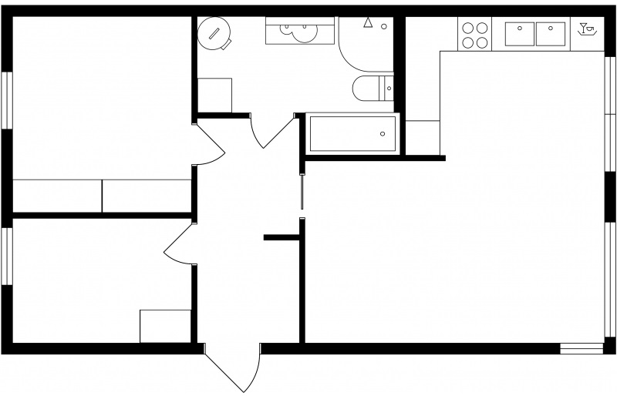

Section 4: Dialogue Creation
Instructions: Write the questions you will ask your partner about their own house using ASL syntax (word order). Then write your partner’s answers in the using ASL syntax. Practice asking and answering. Switch roles and then answer your partner’s questions. Attach another piece of paper if you need more space. You will record this dialogue in the next section. Ask for help when necessary.
Signer 1:
Signer 2:
Signer 1:
Signer 2:
Signer 1:
Signer 2:
Signer 1:
Signer 2:

