JLP26 Haunted House (Chapter 18)
STOP: Before you begin this activity, open and follow recording instructions here.

Pair # _________

Partner A: ________________________________
Student ID: _______________________________
Instructor: ________________________________
Level: ______________ Date: ________________
Partner B: ________________________________
Student ID: _______________________________
Instructor: ________________________________
Level: ______________ Date: ________________

All links in this activity direct to the JLP Activities page on the LLC website. Find your activity number and click the drop down to find links to videos, audio, and/or websites used in this activity.

Section 1: Vocabulary Mastery
Instructions: Write the translation of the following words and phrases into Japanese. Try to use your book and your partner before using other materials or the internet. In the third column, draw a picture, write a note to yourself or put some kind of pronunciation guide for Japanese. Use the third column to help remember the word in Japanese.
Vocabulary | Translation | Notes/Pictures/Pronunciation Guide (anything to help you)
- rat
- candle
- flashlight
- haunted house
- ghost
- curtain
- (someone) turns something on
- something turns on
- (someone) drops something
- something drops
- (someone) breaks something
- something breaks
- (someone) takes something out
- something goes out
- (someone) opens something
- something opens
- (someone) closes something
- something closes
- (someone) puts something inside
- something goes inside

Concept Check: Transitivity Pairs
Although similar, there is a distinct difference in Japanese about when an action is done by humans versus when the action is done on its own. Using incorrect verbiage may lead to others confusing when something happens with someone’s assistance and without someone’s assistance. Transitive verbs describe when an action occurs due to the subject’s interference. Intransitive verbs describe when an action occurs without human assistance.
When encountering transitive verbs, we use the particle を to describe what someone has done to an object. When encountering intransitive verbs, we use the particle が to describe what happened to an object without human interference. There is no pattern for this grammar point, so memorizing the differences will be key. For example, using 電気をつける implies that you turned on the light. Meanwhile, using 電気くがつく implies that the light turned on by itself. Let’s practice with some examples.
きみこさんはおもちゃ＿こわしました。(Kimiko broke the toy.)
おもちゃ＿こわれました。(The toy broke.)
（私は）カップを＿＿＿＿＿。(I dropped the cup.)
カップが＿＿＿＿＿。(The cup dropped.)

Section 2: Describe the Haunted House
Instructions: Look at the picture below. Have each partner describe two activities that are happening in the diagram. Write your descriptions in the space provided on the next page.
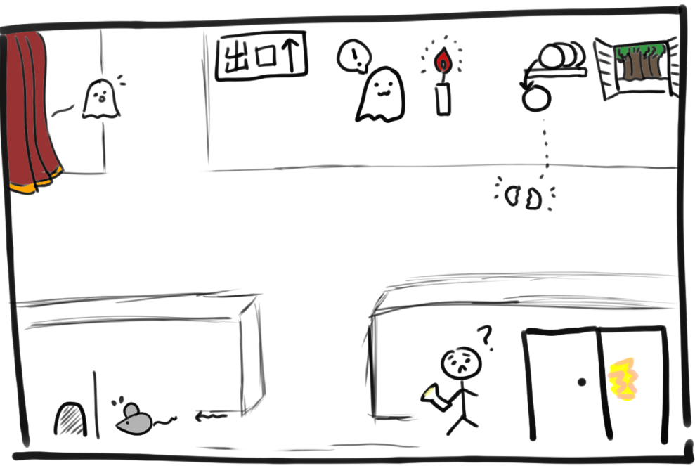

Partner A:
- _________________________________________________________________________________________
- _________________________________________________________________________________________
Partner B:
- _________________________________________________________________________________________
- _________________________________________________________________________________________
Go to the next page!

Section 3: Haunted House Dialogue
You and your partner are dared to enter a haunted house together. Create a conversation as you enter and leave.
Instructions: Use the space below to help create the conversation. The conversation should be 2-3 minutes. You will record this dialogue in the next section. Ask for help if necessary.
Speaker 1:
Speaker 2:
Speaker 1:
Speaker 2:
Speaker1:
Speaker 2:
Speaker1:
Speaker 2:
Speaker 1:
Speaker 2:

Section 4: Record and Save Your Recording
Instructions: Perform the dialogue you created with your partner. Make sure you do not end your Zoom meeting until you have performed your dialogue with your partner.

