Make Outlook Default

Quick Example: Let’s say you want to contact somebody whose email is listed on the Mt. SAC website
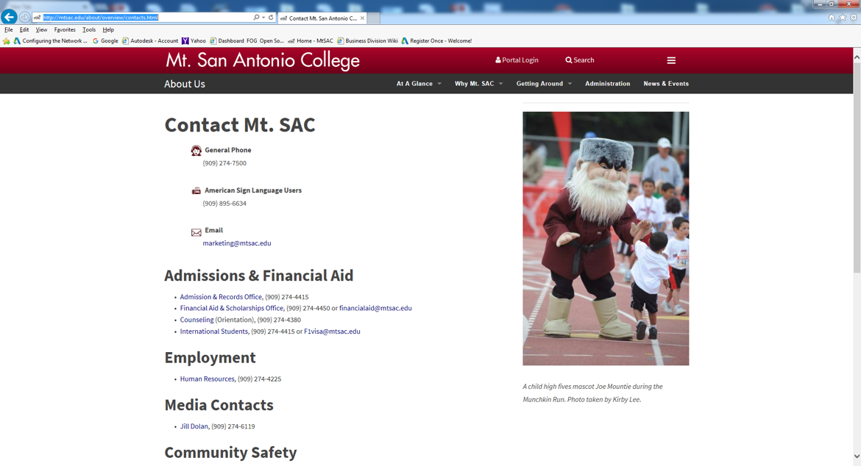

And you click on the email link to email to marketing@mtsac.edu.
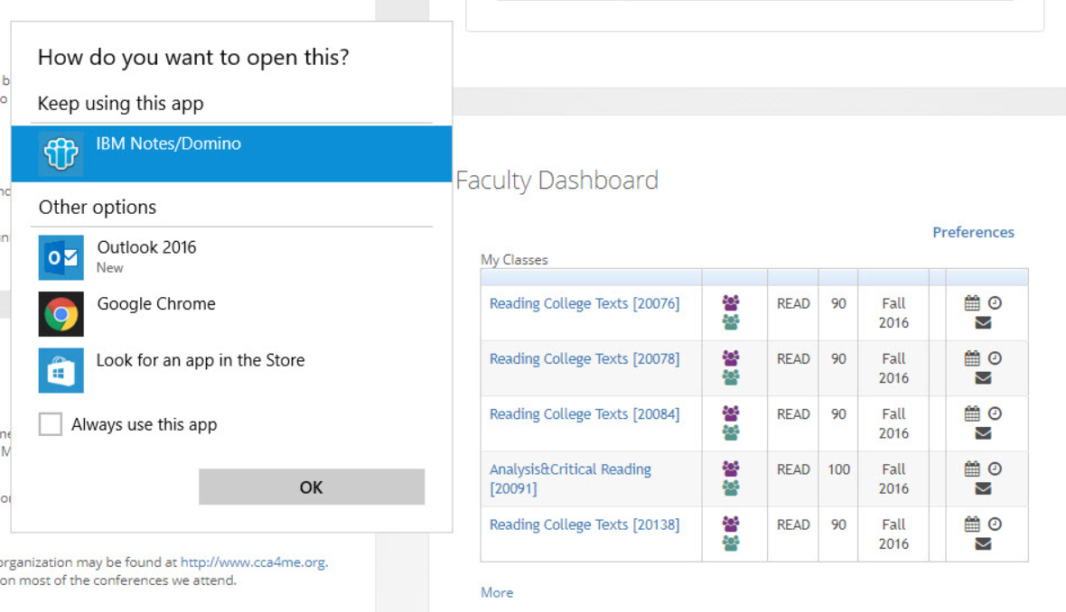And it opens with Lotus notes instead of outlook:
Here are instructions to change the default program.

*These instructions are for Window 7 Operating Systems.

- In Internet Explorer, click on Tools(the small gear on the top right hand corner of the window, under the red X) and choose “Internet Options” from the drop down menu

- In the pop-up window that appears, click on the “Programs” tab (second from the left)
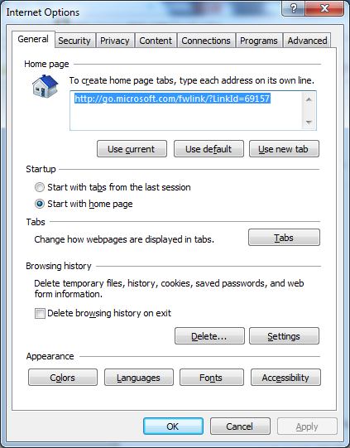

- Then click on Set programs:
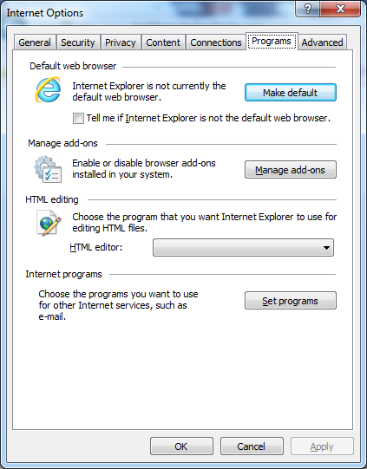
- It will take you to the “Default Programs” window. Then Click on “Set your default programs”
Click on “Outlook 2016” to highlight it, then click on “Set this program as default” and click on ok exit.
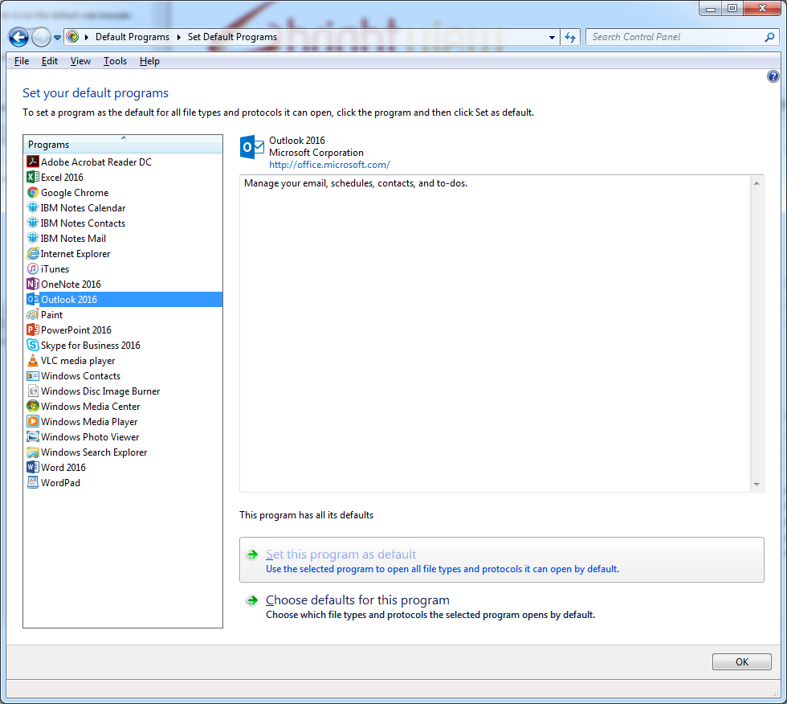

*These instructions are for Window 10 Operating Systems.

- Click on the Start button (windows logo at the bottom right hand corner of the screen) and click on windows System and select Control Panel from the drop down menu.

- 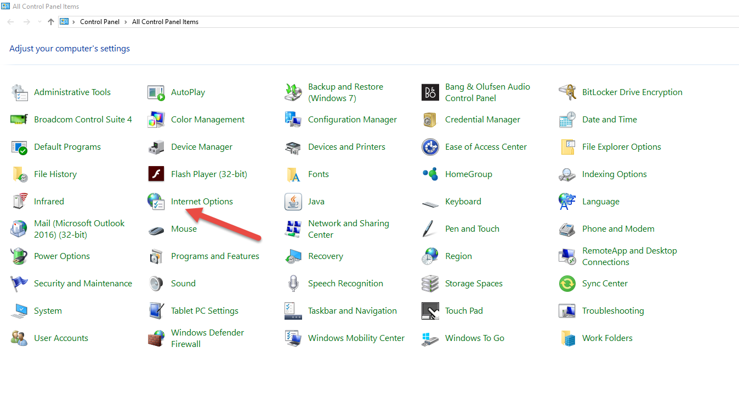Then select Internet Options from the list
*If you do not see the above view in your control panel, select the “View by:” option under the control panel search box, and change the view from “Category” to “Large Icons”

- 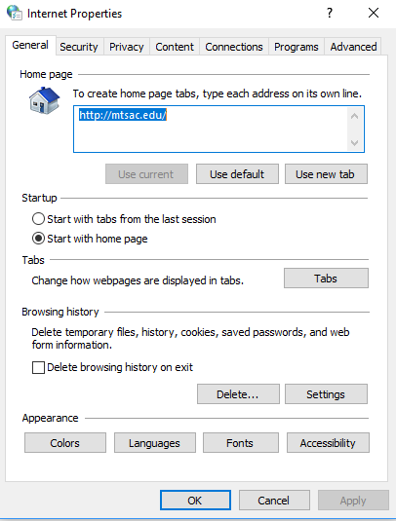In the Internet Options pop-up window, click on the programs tab.
- 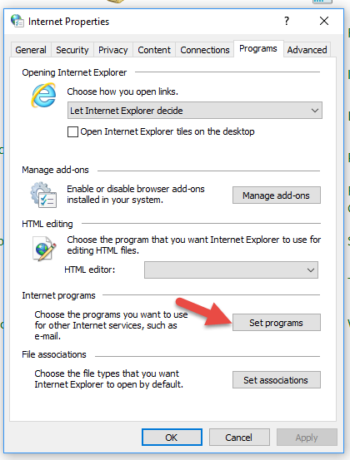In the programs tab, click on the “Set Programs” button
- 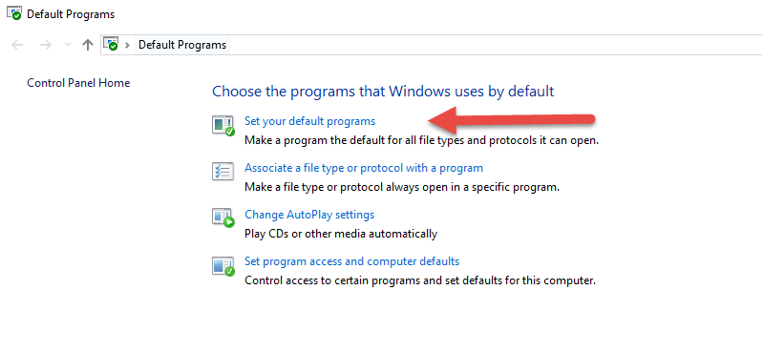Then, in the next pop-up window, click on “Set you default Programs”

- Next, click on “IBM Notes/Domino” under the title “Email”
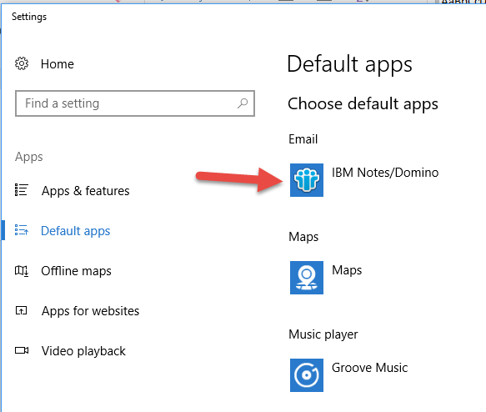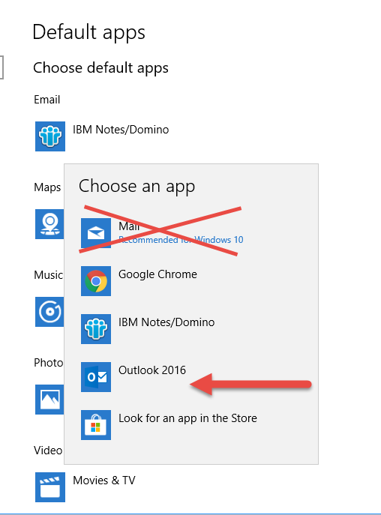
Finally, select “Outlook 2016” from the drop-down menu.

