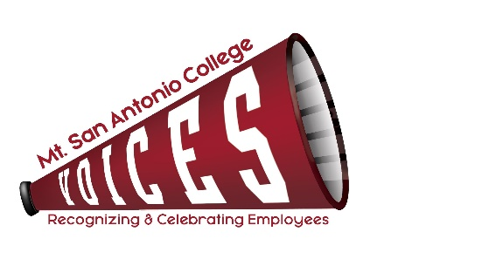
Minutes for April 13, 2020
12:30 to 1:30 p.m., Zoom Meeting

VOICES
 | Loralyn Isomura – Appointed by CSEA 262 | X | Ralph Jagodka – Appointed by Faculty Association
X | Reyna Casas – Appointed by Classified Senate | X | Ruben Flores – Appointed by CSEA 651(Co-chair)
 | Lianne Greenlee – POD Director | X | Melissa Cone – Appointed by Confidentials (Co-chair)
X | Francesca Rinaldi – Appointed by Academic Senate | X | Desiree Marquez – Appointed by Management Steering
X | Julie Laverty – Appointed by the President
 |  |  | Guest:

ITEM | DISCUSSION | OUTCOME
Minutes | Review March minutes | Melissa motioned to approve, Ralph seconded, minutes approved by acclamation.
Way to Go, Joe! | Current status  To-do’s | VOICES Committee selected FCLT as the next recipients. Ruben had previously reached out to them but hadn’t heard back, will follow up and also check with marketing for Newsroom posting.
Shout Out | Spring into the April and Shout Out – Sent 4/5 | Desiree will work on creating certificates the week of 4/19 and Melissa will send out from VOICES Email.
2020-21 Goals Check-in | Committee website up-to-date  - Minutes  - Photos  - 2020 College Champion Award recipients | Julie updated all minutes, shout out recipients, Melissa added names and photos of 2020 College Champion award recipients.
Gifts/Promotional Items | Employee Appreciation Day – Mask giveaway  - First batch mailed  - Next Order  - Discuss second announcement  - Additional mailing | Thank you to committee and POD for working diligently to send approximately 400 masks to employees for the first batch.  Lianne confirmed that Risk Management has received an additional 500 masks, which are ready to be sent.  Melissa will send out another Campus Announcement and VOICES will mail out more masks based on new requests received in two weeks.
Return to Campus | Posting of Yard Signs  - Date  - Locations on campus  - Marquee posting on Temple Ave. | Committee agreed that July 1 was a good time to post signage as the majority of classified and management staff will be on campus by then.  Desiree will work on design for “Welcome Back Mounties from VOICES” for the marquee and possibly social media.  We will discuss locations for campus signage at future meeting in May or June.
Coming Soon | College Champion Awards (June 2021) | Melissa/Ruben will reach out to the President’s Office to confirm awards are proceeding as usual for 2021 and will discuss at May meeting.
2019-20 Meeting Dates & Times | Confirmed 2nd Tuesday of each month, 12:30-1:30pm  Outlook invites sent to committee
Next Meeting | TENTATIVELY: Tuesday, June 8, 2021 – 12:30-1:30 pm – Zoom Meeting

TOPICS FOR FUTURE MEETINGS
Website
Repository
Award listing – descriptions of each award to be added
Use of Mt. SAC Social Media, Marquee, and tv screens across campus as additional outreach
Night Shift Thank You’s - once we are back on campus

