P | Tania Anders  (co-chair) | A | Lianne Greenlee | P | Linda Chan | P | Emily Versace | P | Kelly Rivera | P | Yolanda Haro |  | VACANT: student AS
P | Michelle Sampat  (co-chair) | P | Tamra Horton | A | Sun Ezzell | P | Shiloh Blacksher | A | Dalia Chavez | P | Carol Impara | A | Danny Cantrell
 |  |  |  |  |  |  |  |  |  |  |  | P | Scribe: Elda Blount

Item | Outcomes | ACCJC Standards
- Approval of Minutes  - December 10, 2020 | - Council approved December 10, 2020 minutes with title edit. | - II.A.2  - II.A.7  - II.A.14  - II.A.2  - II.A.7  - III.A.14
- Report Out  1. FLAC  2. FLEX  3. PGI  4. GP Cross-Council Committee | - No report (Sun not in attendance)  - Spring 2021 Flex Day was well attended with 489 participants, double the typical engagement for this annual event. Faculty, staff, and managers were in attendance. Dr. Sara Goldrick-Rab gave the keynote on how faculty can be inspired to reduce barriers to success for diverse community college students.  The annual post Flex Day survey is currently open. So far 153 survey submissions. Feedback will help inform future professional development offerings.  - 33 Winter Blitz sessions took place over Winter session. PGH tracking Smartsheet in beta status. Next step is to incorporate Payroll timesheet for compensation. Next phase in the PGI project is creating a flowchart on Column Crossover. Topics to include will be: What is column crossover? How to get over the columns?  - GPS received five mini grant submissions over Winter 2021 semester. These submissions will be reviewed week of 3/15/21. Council approved to submit mini grant proposal on behalf of FPDC for funding to be used for a graphic designer to create professional development flowcharts. | - II.A.14  - II.A.2  - II.A.7  - III.A.14
- Guests | - Who should we invite next?  - New VPI suggested dates 5/13/21 or 5/27/21. Elda will submit request to Laura Martinez.  - FCLT  - Peggy Marci and Tech Week Coordinators  - Title V Grant Project Lead and/or Coordinators | - II.A.2  - II.A.7  - III.A.14  - III.A.8  - III.C.1
- Action Items  - FPDC 2020/21 goals subgroups | - Updates made to subgroup team members:  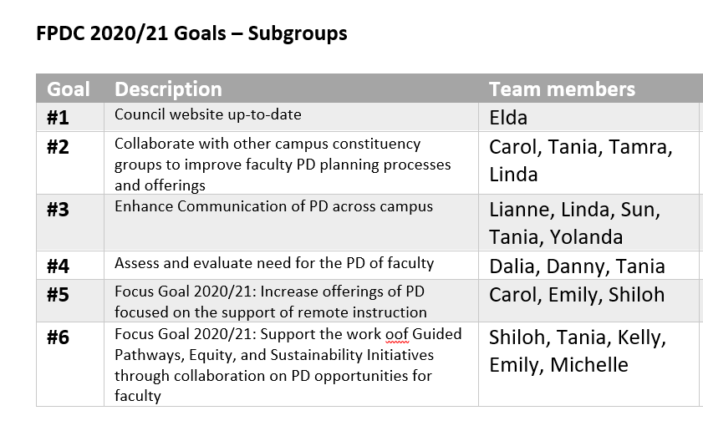 | - II.A.2  - II.A.7  - III.A.14
- Discussion Items  - Content Expert List For PGI proposals  - Mt. SAC Communities of Practice  - PD offerings after conference/workshop attendance  - PD videos: Serving on committees 101 | - Discussion topic will be added to next FPDC meeting 3/25/21. Elda will include Activity Proposal Form as document to review for next meeting. Tania and Michelle will look into process origination. Continuation of work will be held out to subgroup #2.  - Council discussed creating Community of Practice flowchart that will address how to create and join a community of practice. This flowchart is to be house on the POD website.  - Council discussed possibly adding language to the conference and travel funding form to approve sharing post conference refelction to be added to weekly faculty newsletter. Tania will take suggestions to PDC.  - Council discussed content to be covered in videos. Council homework: Think about what content should be covered in the video and think about content experts that can contribute to the videos. | - II.A.2  - II.A.7  - III.A.14  - III.A.8  - III.C.1
- Informational Items  - BP/AP 7160  - Conference and Travel  - Salary and Leaves Approved PGI Recommendations  - Student Rep: Erick Chavez  - PGI Recommendation(s) | - Approved at PAC (Jan 13th 2021)  Board Feb 24th 2021 (Information item)  Approved at Board meeting on March 10, 2021  - Chrome River goes into effect in April (for reimbursements)  - As of 1.12.21  - At the Intersection of Sustainability and Equity  - Contextualizing Data Through Student Voices  - EAB/Navigate - Early Alert System, Impact on Equity  - Equity-Minded Pedagogy and Data Accessing for Effective Teaching  - Examining Equity and Diversity in the Faculty Hiring Process and Beyond  - Interrupt Isms: Speak Up, Point Out, and Call In, Part I & II  - Lights, Camera, Caption! Accessible Videos & Conferences Made Easy  - Next Level Design with Cidi Labs DesignPLUS in Canvas: Using the Intermediate and Advanced Tools  - Show and Tell with VoiceThread and Closed Captioning  - Spark Curiosity! A Question Formulation Technique Workshop  - Starting the Conversation about Plagiarism  - Staying "Woke" in Class: teaching Practices that Promote Equity  - Student Services Weathering the Storm, Keeping Focused on Moving the Needle  - TILT Outcomes Toward Success  - Academic Literacy for Equity  - Student Rep Erick Chavez is no longer available to serve on council. Tania will reach out to Andrea Sims, Director of Student Life, for recommendations.  - PGI recommendations will be reviewed during next FPDC meeting to explain voting process to new members. | - II.A.2  - II.A.7  - III.A.14  - III.A.8  - III.C.1

