Distance Learning Committee
2021-22

PURPOSE: The purpose of the Distance Learning Committee is to discuss, review, and evaluate distance learning modes of instruction, and recommend and promote best practices and new opportunities for distance learning and teaching.

FUNCTION: The Committee's functions are to:
- evaluate and recommend approval of Distance Learning Course Amendment Forms
- recommend policy changes pertaining to distance learning
- evaluate and promote a variety of effective practices and standards for distance learning
- provide a forum for sharing and collaboration among distance learning faculty by sponsoring informational meetings, discussions, and workshops pertaining to distance learning
- facilitate the implementation and update to the Distance Learning Master Plan
- coordinate with campus committees and other constituencies with regards to distance learning

X | Matthew Dawood | X | Michael Dowdle | X | L.E. Foisia | X | Hong Guo | X | Mike Hood
X | Carol Impara, co-chair | X | Tammy Knott-Silva | X | Catherine McKee | X | Stacie Nakamatsu |  | Michelle Newhart
X | Rich Patterson | X | Romelia Salinas, co-chair |  | Eric Turner | X | Sandra Weatherilt |  | Student Rep:  To be appointed
Guests: Oli Mohammedi, Kelly Rivera, Ed Estes

MINUTES – October 12, 2021

AGENDA ITEM | DISCUSSION/COMMENTS
Approval of DLC minutes: assign themes  September 28, 2021 | Approved
Reports:
Educational Design Committee (EDC) /Curriculum and Instruction Council (C&I) (Carol) | C&I accepted the following DLC minutes: 8/24/21  The SPOT Equivalency Criteria recommendation was on the agenda at C&I but the committee did not get to it at the 9/28 meeting. Hopefully it will be discussed at the meeting later today.  IB9
Information Technology Advisory Committee (ITAC) Report (Rich) | Two new members were introduced:  - John Uy, a new student member  - Angelic Davis, a new member from Administrative Services  The Goals document was reviewed. The committee discussed the six proposed goals and edited goal six on technology literacy to include sustainability  The committee reviewed the Purpose and Function statement. The membership was updated to add the new members  Michael Carr explained the concept of a ‘Hytech’ Classroom. The room would include technology to allow a faculty member to teach both in-person and remote students. IT is working with other areas like Instruction and Technical Services to define what would be needed to transition some classrooms to this environment. It would require training of faculty members and IT support staff to maintain these classrooms. Some classrooms in the Business Division might already have most of the technology needed to do this type of teaching format.  Note: HyTech was called HyFlex in previous DLC meetings  IIA, IIIC
Faculty Learning Activities Committee (FLAC) Report (Catherine) | Has not met yet.
Faculty Center for Learning Technology (FCLT) Report (Michelle) | Professors and students have been reporting an issue with Honorlock. Hugo made a video for faculty on how to fix it, and we added the video to our Honorlock page in CFC. The Canvasadors added info for that in MSH Honorlock page as well as additional information about Honorlock privacy and security. We’ve made several updates to the Mountie Student Hub tools page recently.  FCLT is working on self-paced versions of Easy and Engaging Videos with Canvas Studio and Canvas for Teaching on Campus. Studio is the first priority. Also working on a survey to collect Harmonize feedback from faculty.  IIA, IIIC
Student Report
DL Amendment Forms
FCS 61  FCS 70  FCS 80  FIRE 3  KORE 3  KORE 4  SOC 36  VOC AR 202  VOC BS 33  VOC CNT 64  VOC CNT 66  VOC FSH 08  VOC FSH 14  VOC PHO 26 | Approved  Approved  Approved with added topics week 6  Approved with edits week 3, 15, 16  Approved with edits weeks 1, 9  Approved with edit course title, new course  Approved with edits: see PM time, check accessibility checkbox  Approved  Approved with activity edits  Approved  Approved with fix activity in week 1  Approved  Approved with add LO  Approved  After making corrections, the approved forms will be moved to EDC.  IIA, IIIC
Discussion
Goals | The DLC agreed to 10 goals.  Carol will move goals forward to the President’s Office and C&I.  IB9, IIA, IIIC
SPOT Report | Current SPOT-certified faculty: 704. There are 566 faculty members enrolled in SPOT. Courses submitted in mid-September are currently under review. All courses submitted by the August 1 submission deadline for possible winter certification have been reviewed, feedback provided, and most have been certified. October 1 was the submission deadline for possible certification for spring 2022.  SPOT reviewers (Mike, Sandra, Catherine) are excited to start working with the new Online Equity Coordinator, Oldooz (“Oli”) Mohammadi.  IIIC
DL Amendment Form Process, continued | With DL Forms in WebCMS on hiatus, the Word document needs updating to reflect FOMA. Suggested to remove signature page since department and division oversight is indicated by minutes.  Carol will move form to C&I for review.  IB9, IIIC
H.4.C | With the change in federal and state regulations, Faculty Association has requested that DLC make a recommendation to update the H.4.C. DLC reviewed the current H.4.c and new DE regulations language.  DLC will resume discussion next meeting.  IB9, IIA
POCR Update | Mt. SAC now has 13 courses deemed “quality reviewed” and aligned to the CVC Course Design Rubric. Another course has been submitted and is in the process of being evaluated by the CVC.  Of 14 courses submitted, eight have been reviewed by the POCR Team. This chart can be accessed at Mt. SAC POCR Dashboard  https://app.smartsheet.com/b/publish?EQBCT=4c31217b5fb1438c8164c72d0d5a34c7  IIA, IIIC

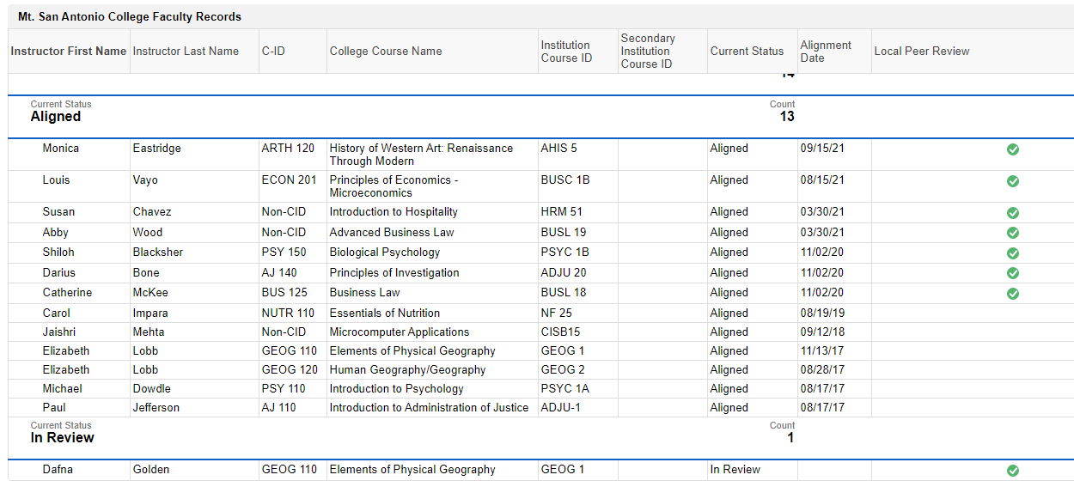
Figure 1. POCR Dashboard as of October 2021
Fall 2021 semester dates – 8 meetings – as needed (finals week, summer are possible)
DLC Meetings - 2nd and 4th Tuesdays at 1:15 – 2:45 PM online via Zoom
DLC website: https://www.mtsac.edu/dlc/
DLC listserv: dlc@mtsac.edu

DLC Accreditation Themes:
- IB9. Assuring Academic Quality and Institutional Effectiveness Academic Quality – Engages in continuous, broad based, systematic evaluation and planning
- IIA. Instructional Programs – Uses delivery modes, including DL, in support of equity
- IIB. Library and Learning Support Services – Provides library and other learning support services to support educational programs, including DL
- IIC. Student Support Services – Evaluates and demonstrates that student support services support student learning in various modes, including DL
- IIIC. Technology Resources – Provides support in the use of technology
- IIIA14. Human Resources – Provides all personnel with appropriate opportunities for continued professional development.

The following courses requested that their Distance Learning Amendment forms be changed from FOMA to traditional DL. (with Department Approval)

ARCH 101
ARCH 102
ARCH 121
ARCH 122
ARCH 141
ARCH 142
ARCH 145
ARCH 147
ARCH 201
ARCH 202
ARCH 221
ARCH 222
ARCH 247
ECT 16
ECT 17
ECT 26
ECT 67
ECT 70
ECT 71
ECT 87
R-TV 01
R-TV 14
R-TV 19A
R-TV 28

