# Online Self Registration Process:

1. This is the landing page when the student logs in to Banner Self Service. Student clicks on Student tab: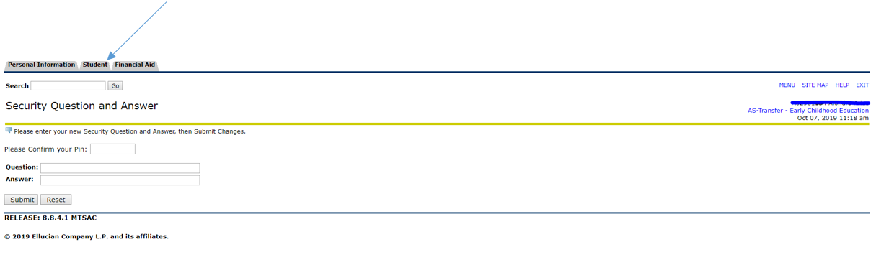  
2. Student will go to Registration:

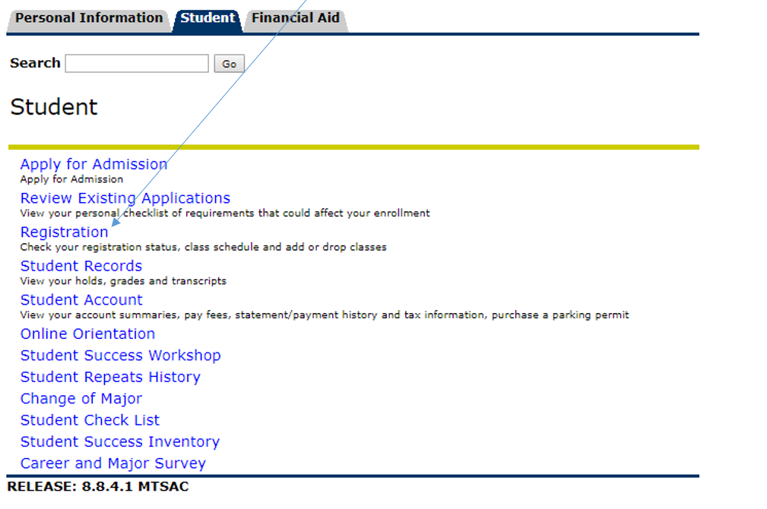

3. Student will go to add or drop classes:

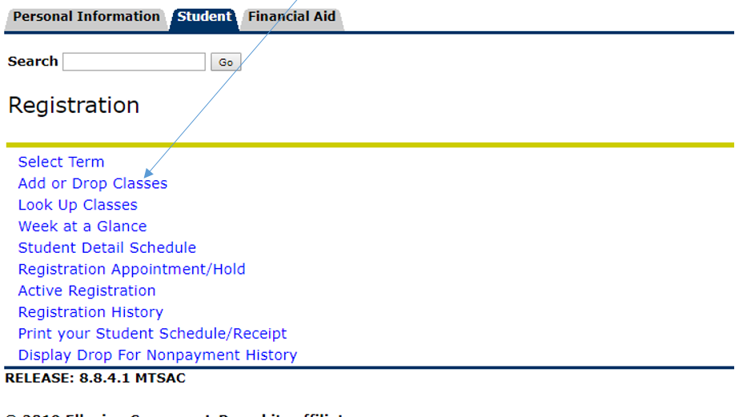

4. Student will select the term:

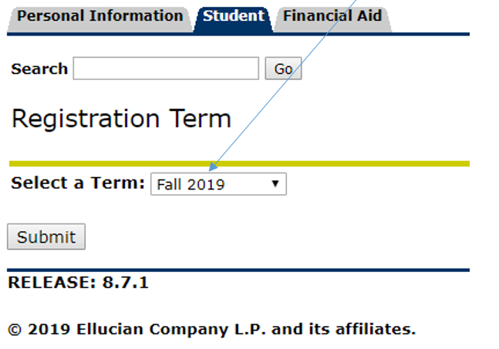

5. Student enters the CRN and hits enter key or clicks on the submit changes button:

