Fred and Marion Coble Scholarship Application
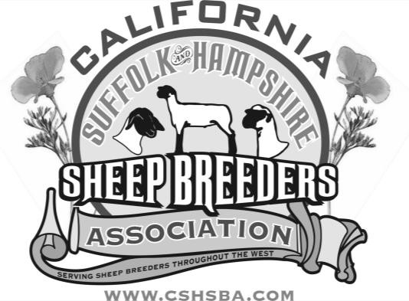

Due: May 15th, 2024
Will be presented at the Reno Nugget Show and Sale.

Send Applications to:
Marlies Boyd cshsba@gmail.com
California Suffolk & Hampshire Sheep Breeders Association

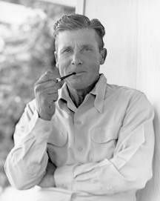
FRED AND MARION COBLE
1902-1978

Fred Coble, native of Potter Valley, California, spent most of his life working with sheep. Together with his wife, the former Marion Moore, he owned and operated the Green Valley Ranch near Winters.

The Coble Suffolks were known throughout the United States and Canada as winners in the show ring. They also sold at premium prices at the ram sales. Fred's animals were judged Grand Champions at county fairs all over California, state fairs in Oregon and Arizona as well as California, and many regional fairs such as Ogden, Utah and Canadian livestock expositions. One of the more prestigious winnings was of the English Cup at the Chicago International Exposition.

Fred Coble's ability to judge sheep was recognized by his peers. He was invited to judge at the major North American livestock expositions including the Chicago International, British Columbia International, the Grand National in San Francisco, and the California State Fair.

Fred also served the livestock industry. He was one of three founders of the California Suffolk Association and also served as president. He was president of the American Suffolk Sheep Society, a director of the National Suffolk Sheep Society, and a 42-year member of the California Wool Growers Association. The Coble Suffolks are remembered for their size, bone, and characteristic heads. They made a lasting impression on the Suffolk breed.

FRED & MARION COBLE
CALIFORNIA SUFFOLK & HAMPSHIRE SHEEP BREEDERS ASSOCIATION ANNUAL SCHOLARSHIP

Eligibility
  - High school graduating senior to an accredited Junior College or four-year University or State College.
  - Student currently enrolled in an accredited Jr. College or four-year University or State College.
  - Proof of acceptance or enrollment, required.
  - Must have and maintain a grade point average of 2.0
- Announcement
  - Scholarship Applications are due to CSHSBA by May 15, 2024.
  - The scholarship application is available online at www.cshsba.org
  - The board may allocate scholarships at their discretion.
- Qualifications
  - Involvement with the Suffolk/Hampshire Breed.
    - Applicant with involvement in sheep breeding programs will be selected over applicants with market lamb projects.
    - Preference given to students who have raised Suffolk and/or Hampshire Sheep. Although, all students involved with the sheep industry will be considered.
    - Applicant must be a member or part of a family membership of CSHSBA.
  - Extra-Curricular Activities including:
    - 4-H
    - FFA
  - Scholastic Achievement
    - Scholarship to be based on merit, not exclusively on financial need.
  - Scholarship cannot be presented again to previous recipient.
  - Evaluation of candidate:
    - 60% Project
    - 20% Extra Curricular * 20% Scholastic Ability

Fred and Marion Coble Scholarship Application
The California Suffolk & Hampshire Sheep Breeders Association Scholarship Program is in recognition of the Coble’s contribution to the sheep industry in California and throughout the United States.
Application packets must be postmarked NO LATER THAN May 15th, 2024 and mailed to: California Suffolk & Hampshire Sheep Breeders Association, 17199 Carrolton Rd., Escalon, CA or email cshsba@gmail.com. For additional information, email Marlies Boyd at cshsba@gmail.com

Applicant’s Name:

County of Residence

Permanent Address:

City:
State:
Zip:

Applicant’s Telephone:
Fax#:

Email:

Parent or Guardian’s Name: Parent’s Telephone:

The applicant must answer and/or complete the following questions:

- Describe how the raising of breeding or market sheep has affected your life? (Not to exceed 1- page)
- Describe your college plans, major, and career objective. (Not to exceed 1-page)
- Attach your resume (Not to exceed one page).

CERTIFICATION AND AUTHORIZATION:
All of the information provided on this application is true and complete to the best of my knowledge. I certify that I will be attending full-time a four-year California College or University or a two-year California Community College or a California Vocational Trade School in the Fall of 2024. I have read and understand the Eligibility and Application Requirements of this Scholarship Program. I understand that if chosen, my scholarship award will be sent to you directly with proof of your enrollment must be provided to the scholarship committee prior to the award being given.

By signing below I certify that I am a CALIFORNIA resident and that the information I have submitted is true and complete to the best of my knowledge.

Applicant’s Signature:

Date:

