# Steps to Obtain a PDF Copy of your Accommodation List

1. Go to <https://www.mtsac.edu/access/> and scroll down to click on “MyACCESS Student Login.”

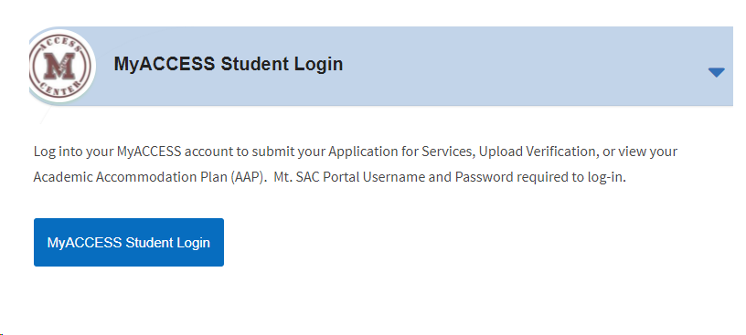

1. 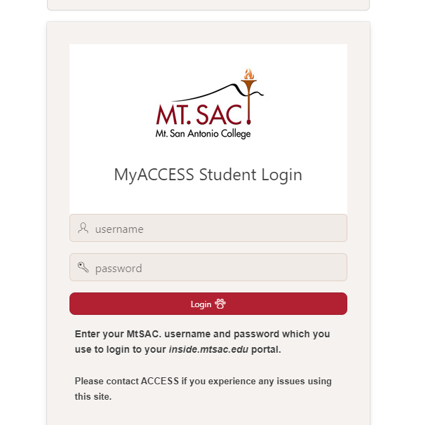Log in to your [MyACCESS Student Login](https://prodapx.mtsac.edu/prodapex/f?p=MYACCESS) using the same Username and Password you use for your Mt. SAC Student Portal. This link is also available by visiting <https://prodapx.mtsac.edu/prodapex/f?p=MYACCESS>

1. Select the blue button called “Download Accommodations for Instructor” and you will see a PDF download. Save the PDF to your computer. Email your professor and inform them which specific accommodations you need for the class.  Attach your downloaded accommodation list as verification of your accommodations.

